No.1:

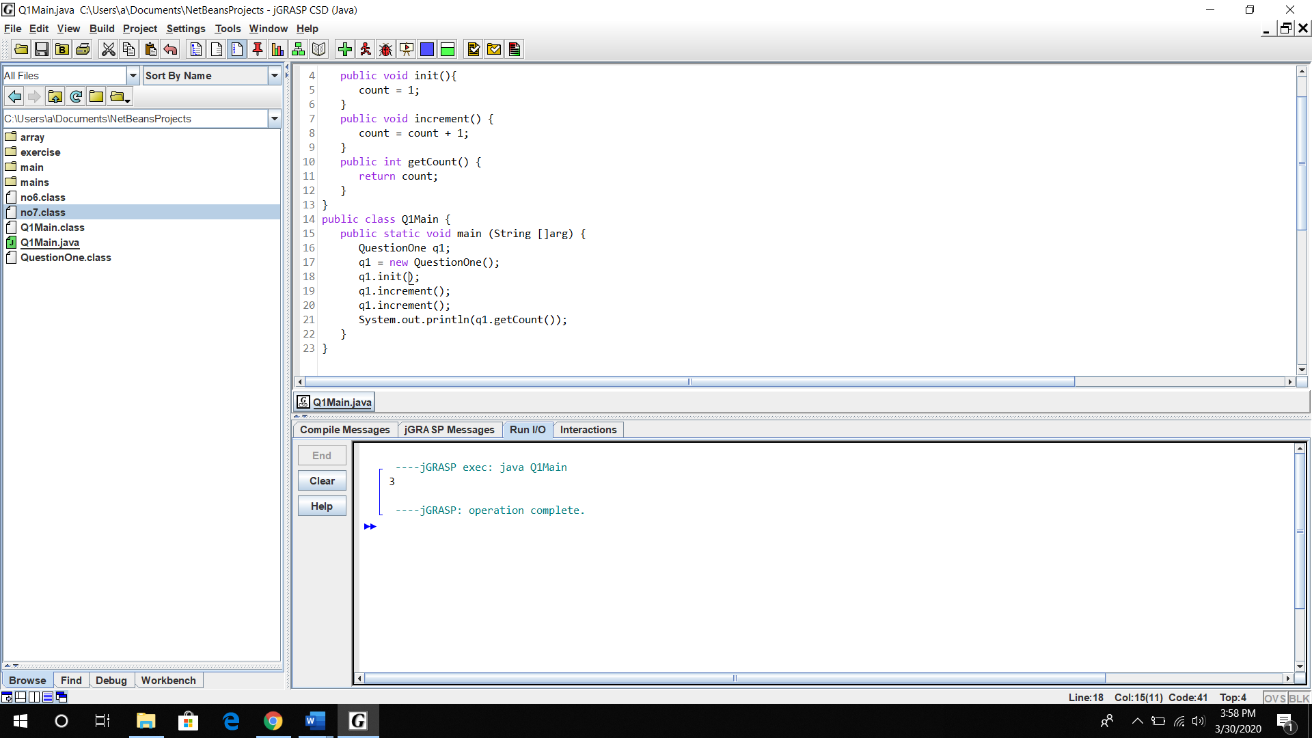

After change

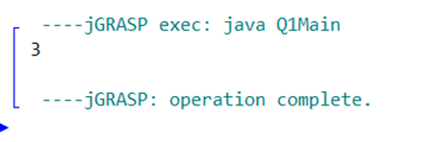

No.2:

a)

|  |
| --- |
| Staff |
| * String name * String staffID * double salary * int workingDay |
| + setStaffInfo()  + calculateSalary()  + getSalary()  + getName()  + getStaffID() |

No.3:

